**LAB CYCLE 2**

**Submitted by**

**SIJI JOSE**

**MCA135**

**LAB CYCLE 2-QUESTION 1**

**AIM:** Create a HTML page to explain the use of various predefined functions in a string and math object in java script.

**PROGRAM CODE:**

<!DOCTYPE html>

<html>

<body>

<p id="abs_demo"></p>

<p id="ceil_demo"></p>

<p id="floor_demo"></p>

Minimum Value: <p id="min_demo"></p>

Maximum Value: <p id="max_demo"></p>

<script>

document.getElementById("abs_demo").innerHTML = Math.abs(-5.6);

document.getElementById("ceil_demo").innerHTML = Math.ceil(7.8);

document.getElementById("floor_demo").innerHTML = Math.floor(5.8);

document.getElementById("min_demo").innerHTML =

Math.min(40, 87, 55, 25, 78, 14);

document.getElementById("max_demo").innerHTML =

Math.max(50, 90, 55, 25, 78, 14);

</script>

</body>

</html>

**RESULT:**

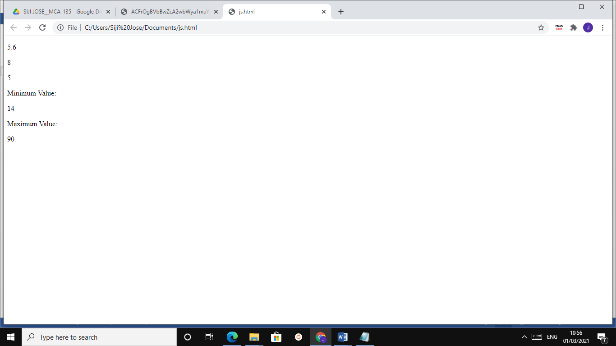

**LAB CYCLE 2-QUESTION 2**

**AIM**: Generate the calendar using JavaScript code by getting the year from the user.

**PROGRAM CODE:**

<html>

<head>

<script language="javascript">

function day_title(day_name)

{

document.write("<td align=center width=35 bgcolor=pink><b>"+day_name+"

</b></td>");

}

function fill_table(month,month_len)

{

day=1;

document.write("<table border=1 cellspacing=3 cellpadding=3%>");

document.write("<td colspan=7 align=center bgcolor=green><b>"+month+"

"+year+"</b><tr>");

day_title("Sun");

day_title("Mon");

day_title("Tue");

day_title("Wed");

day_title("Thu");

day_title("Fri");

day_title("Sat");

document.write("</tr><tr>");

for(var i=1; i<start_day;i++)

{

document.write("<td>");

}

for(var i=start_day; i<8;i++)

{

document.write("<td align=center bgcolor=blue>"+day+"</td>");

day++;

}

document.write("<tr>");

while(day<=month_len)

{

for(var i=1; i<=7 && day<=month_len;i++)

{

document.write("<td align=center bgcolor=blue>"+day+"</td>");

day++;

}

document.write("<tr>");

start_day=i;

}

document.write("</tr></table><br>");

}

year=prompt("enter 4 digit year ",2016);

today=new Date("January 1, "+year);

start_day=today.getDay()+1;

fill_table("January", 31);

if (year%4==0)

fill_table("February", 29);

else

fill_table("February", 28);

fill_table("March", 31);

fill_table("April", 30);

fill_table("May", 31);

fill_table("June", 30);

fill_table("July", 31);

fill_table("August", 31);

fill_table("September", 30);

fill_table("October", 31);

fill_table("November", 30);

fill_table("December", 31);

</script>

</head>

</html>

**RESULT:**

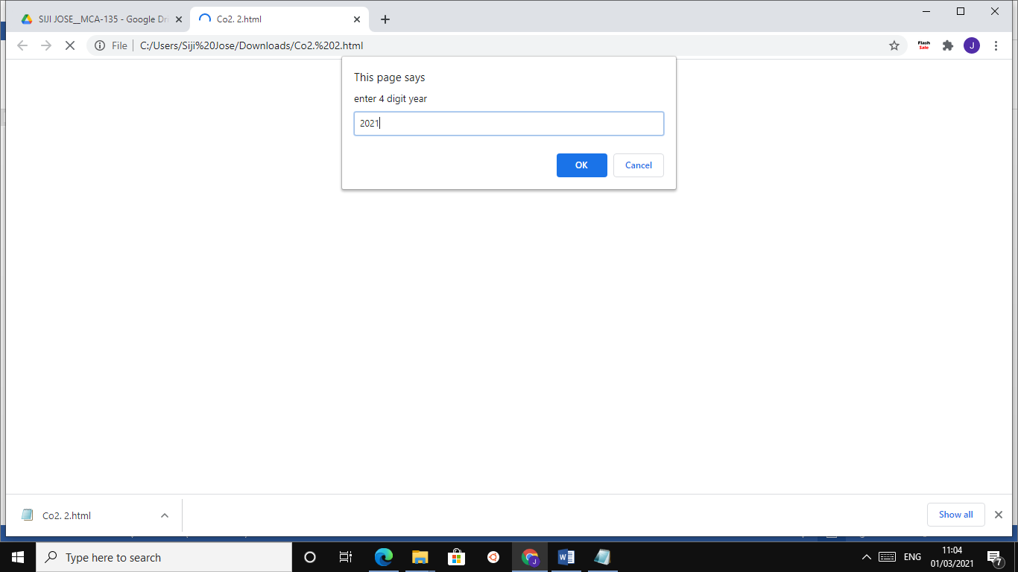

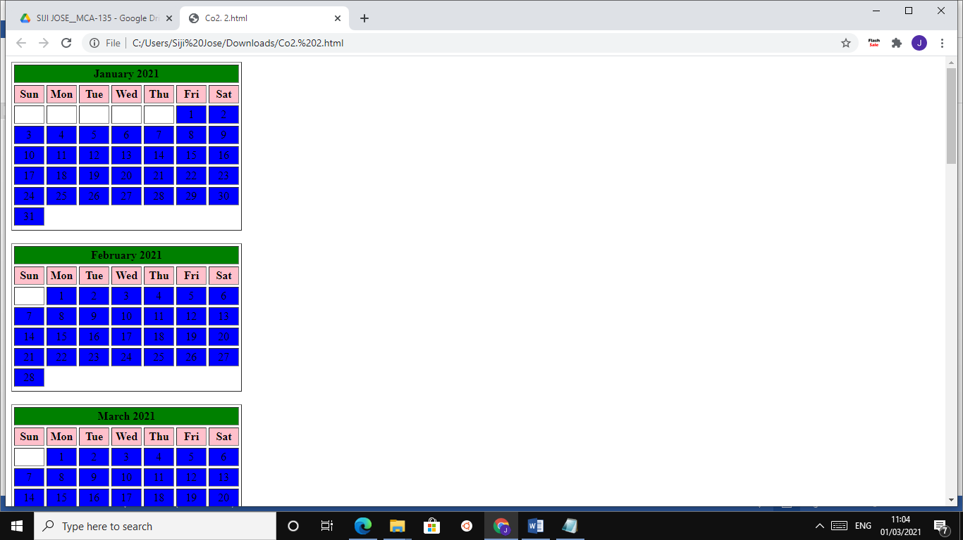

**LAB CYCLE 2-QUESTION 3**

**AIM:** Create a HTML registration form and to validate the form using JavaScript code.

**PROGRAM CODE:**

<html>

<head>

<script>

function validate()

{

var msg="";

if(document.getElementById('log').value=="")

{

msg = "username";

document.getElementById('log').focus()

}if(document.getElementById('pass').value=="")

{

if(msg!="")

{

msg+=" and "

}

msg+="password";

}

if(msg!="")

{

alert("provide "+msg);

return false;

}

}

</script>

</head><body onload=document.getElementById('log').focus()>

<form action="login.php" method="post" onsubmit="return validate();" >

Login-Name: <input type="text" id="log"></br></br>

Pass-word: <input type="password" id="pass"></br></br>

<input type="submit" name="submit1" value="Login">

</form>

</body>

</html>

**RESULT:**

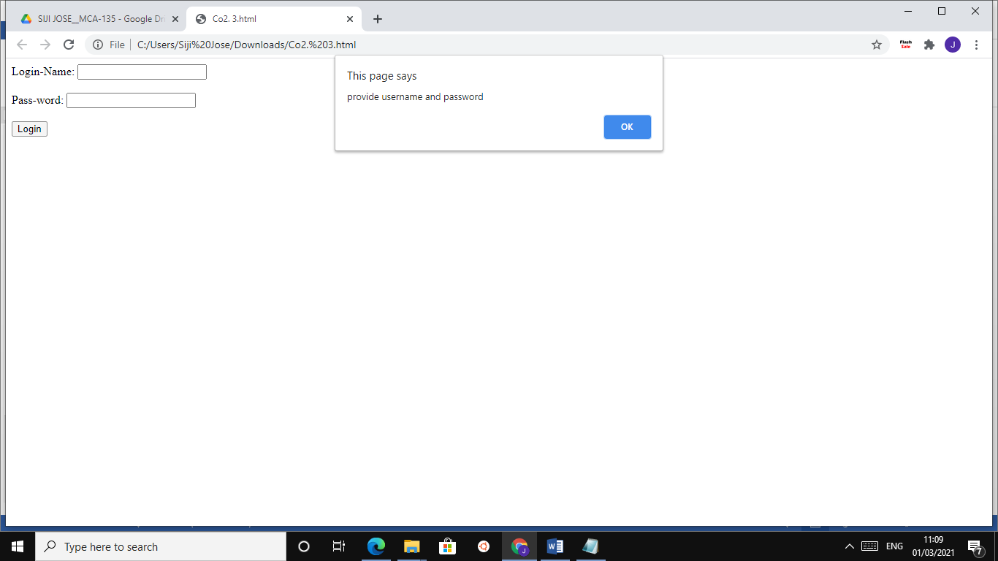

**LAB CYCLE 2-QUESTION 4**

**AIM:** Evaluating JavaScript Event Handling for every click of a button to change the background color of a HTML page.

**PROGRAM CODE:**

<html>

<head>

<script type="text/javascript">

function get_random_color(){

var color='#';

for (var i=0;i<6;i++)

{

color+=Math.round(Math.random())*6;

}

document.body.style.background=color;

}

</script>

</head>

<body onclick="get_random_color()">

<h1>Click me to change my color!</h1>

</body>

</html>

**RESULT:**

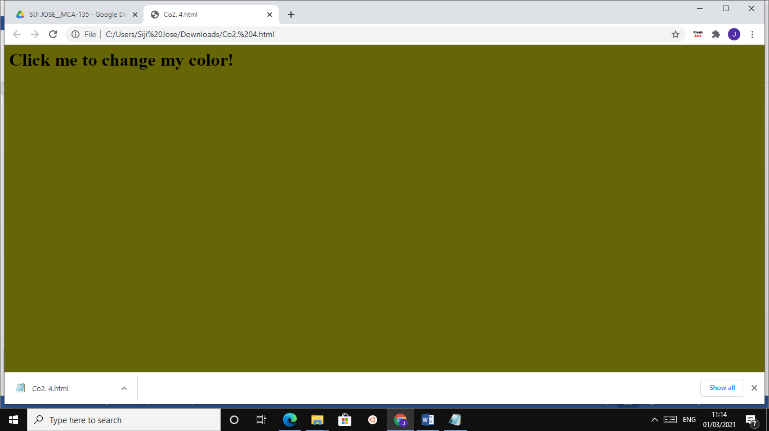

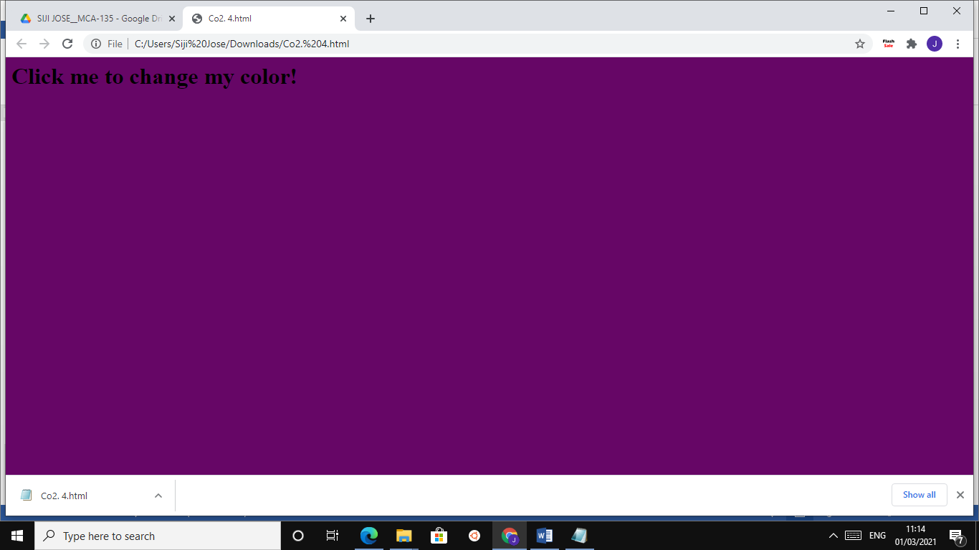

**LAB CYCLE 2-QUESTION 5**

**AIM:** Create a HTML page to display a new image and text when the mouse comes over the existing content in the page using JavaScript Event Handling.

**PROGRAM CODE:**

<html>

<head>

<script language="javascript">

function preload()

{

topon=new Image(100,50);

topon.src="http://tkmce.ac.in/wpcontent/themes/tkm/images/tkmce_logo.png";

topoff=new Image(260,280);

topoff.src="http://tkmce.ac.in/wpcontent/uploads/2014/09/founder.png";

}

function myMouseOn(n)

{

preload();

imageON=eval(n+"on.src");

document.images[n].src=imageON;

}

function myMouseOff(n)

{

imageOFF=eval(n+"off.src");

document.images[n].src=imageOFF;

}

</script>

</head>

<body >

<h1> Demo for mouse over</h1>

<a href="#" onMouseOut="myMouseOff('top')";

onMouseOver="myMouseOn('top')";>

<img src="Koala.jpg" alt="Show Next" name="top">

</a>

</body>

</html>

**RESULT:**

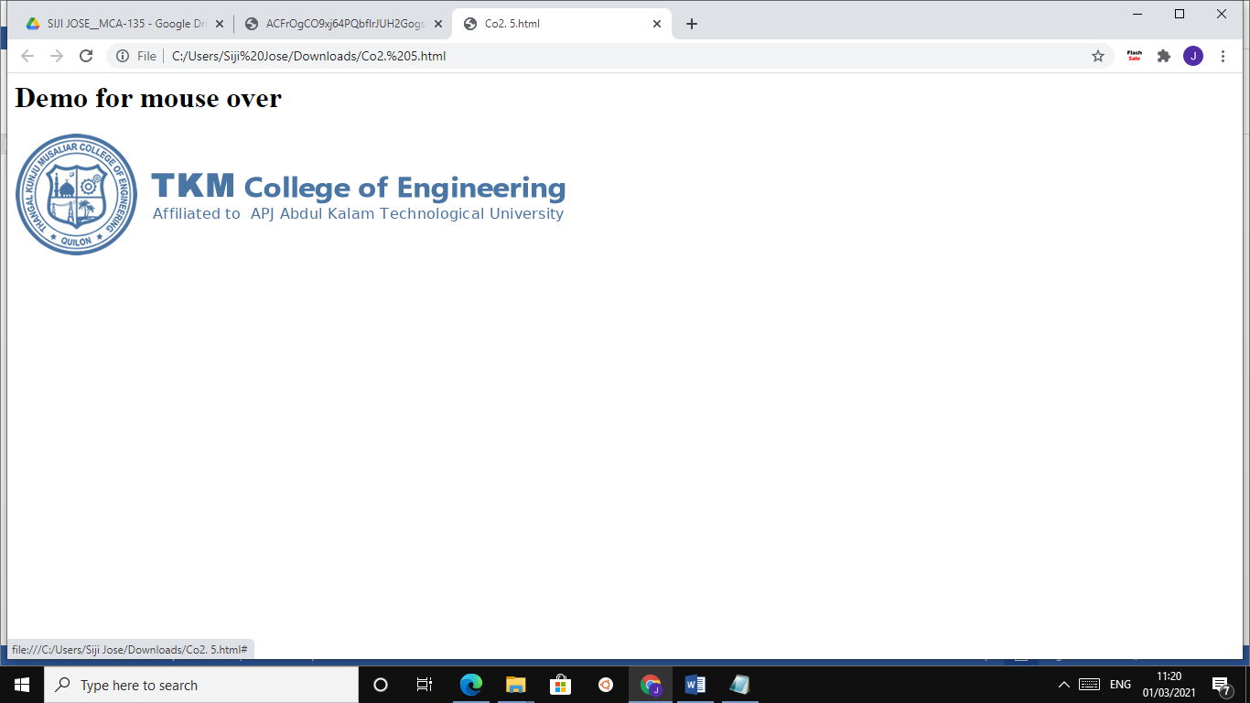

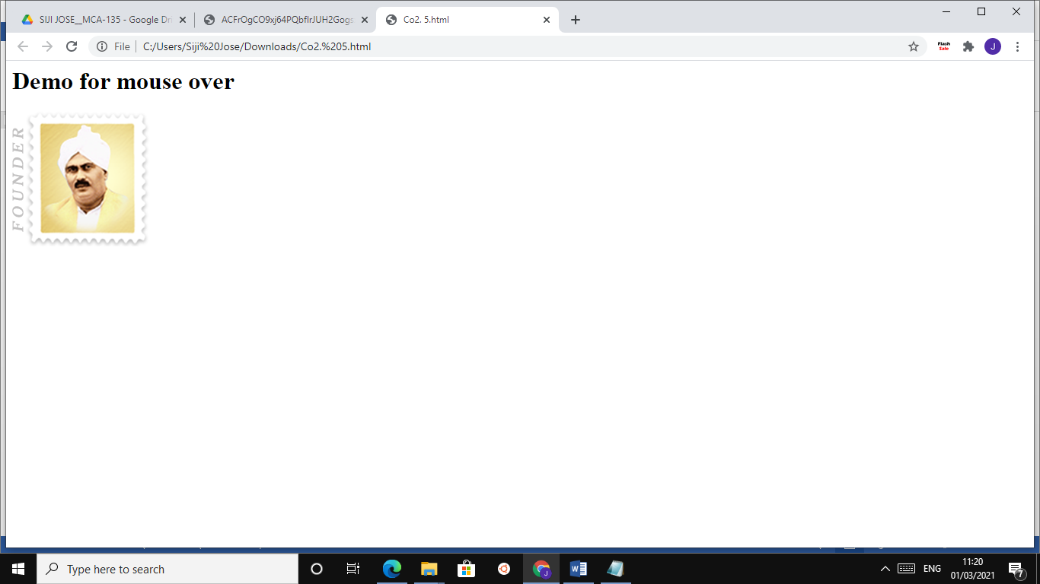

**LAB CYCLE 2- QUESTION 6**

**AIM:** Create a HTML page to show online exam using JavaScript.

**PROGRAM CODE:**

<html>

<head>

<title>Exam</title>

<script language="javascript">

function exam(form)

{

var i=0;

if(form.one[2].checked)

i=i+1;

if(form.three[0].checked)

i=i+1;

if(form.four[0].checked)

i=i+1;

if(form.five[1].checked)

i=i+1;

window.alert("Thank You Taking Online Exam! Your Score is: "+i);

}

</script>

</head>

<body bgcolor=silver>

<form onSubmit="exam(this)">

<center><h1><blink>WELCOME TO ONLINE EXAM FORM</blink></h1></center>

<p>

<h1>1)Which is platform independent language</h1>

<input type="radio" name="one" value="c++">

<label>c++</label>

<input type="radio" name="one" value="c">

<label>c</label>

<input type="radio" name="one" value="java">

<label>java</label>

<input type="radio" name="one"value="basic">

<label>BASIC</label>

</p>

<p>

<h1>2) Which is class of all class in java</h1>

<input type="radio" name="three" value="object">

<label>Object</label>

<input type="radio" name="three" value="math">

<label>Math</label>

<input type="radio" name="three" value="system">

<label>System</label>

<input type="radio" name="three" value="graphic">

<label>Graphic</label> </p>

<p>

<h1>3)Frame package is in which package</h1>

<input type="radio" name="four" value="awt">

<label>AWT</label>

<input type="radio" name="four" value="applet">

<label>Applet</label>

<input type="radio" name="four" value="lang">

<label>Lang</label>

<input type="radio" name="four" value="swing">

<label>Swing</label>

</p>

<p>

<h1>4)Java does not support</h1>

<input type="radio" name="five" value="inheritance">

<label>Inheritance</label>

<input type="radio" name="five" value="multiple inheritance">

<label>Multilple inheritance</label>

<input type="radio" name="five" value="polymorphism">

<label>Polymorphism</label>

<input type="radio" name="five" value="encryption">

<label>Encryption</label>

</p>

<p><center>

<input type="submit" value="Submit">

<input type ="reset" value="Reset">

</center></p>

</body>

</html>

**RESULT:**

